Solved Examples

Ex.1 The vertex of the parabola y2 +6x – 2y +13 =0 is
(A) (1 , –1) (B) (–2, 1)
(C) (3/2, 1) (D) (– 7/2,1)
Sol. We have y2 + 6x – 2y + 13 = 0
⇒ y2 – 2y = –6x – 13
⇒ (y – 1)2 = – 6(x + 2)
Clearly, the vertex of this parabola is (–2, 1)
Ans. [B]

Ex.2 If vertex of parabola is (2, 0) and directrix is
y-axis, then its focus is -
(A) (2, 0) (B) (–2, 0)
(C) (–4, 0) (D) (4, 0)
Sol. Since the axis of the parabola is the line which passes through vertex and perpendicular to the directrix, therefore x-axis is the axis of the parabola.
Obviously Z ≡ (0, 0).
Let focus of the parabola is S (a, 0). Since vertex (2,0) is mid point of ZS, therefore
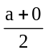 = 2 ⇒ a = 4.
∴ Focus is (4, 0) Ans. [D]

Ex.3 If the focus of a parabola is (1, 0) and its directrix is x + y = 5, then its vertex is-
(A) (0, 1) (B) (0, –1)
(C) (2, 1) (D) (3, 2)
Sol. Since axis is a line perpendicular to directrix, so it will be x – y = k. It also passes from focus, therefore k = 1.
So equation of axis is x – y = 1.
Solving it with x + y = 5, we get
Z ≡ (3, 2).
If vertex is (a, b), then a = 2, b = 1.
Hence vertex is (2, 1). Ans. [C]

Ex.4 The directrix and axis of the parabola
4y2 – 6x – 4y = 5 are respectively.
(A) 8x + 11 = 0; y – 1 = 0
(B) 8x – 11 = 0, 2y – 1 = 0
(C) 8x + 11 = 0; 2y – 1 = 0
(D) None of these

Sol. Here 4y2 – 4y = 6x + 5
⇒ 4 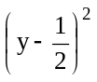= 6 (x + 1)
Put y – = Y, x + 1 = X
The equation in standard form Y2 = X
4a = ⇒ a =
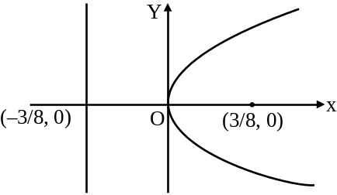
Directrix, X + a = 0
⇒ x +1+ = 0 ⇒ 8x + 11 = 0
Axis is Y = 0 ⇒ y – = 0 ⇒ 2y – 1 = 0 Ans. [C]

Ex.5 The angle subtended by double ordinate of length 8a at the vertex of the parabola y2 = 4ax is -
(A) 45º (B) 90º (C) 60º (D) 30º
Sol. Let (x1, y1) be any point on the parabola
y2 = 4ax, then length of double ordinate
2y1 = 8a ⇒ y1 = 4a
y12 = 4ax1 ⇒ x1 = 4a
∴ vertices of double ordinate are
P(4a, 4a); Q(4a, –4a)
If A is the vertex(0, 0), then
Slope of AP = 1 = m1
Slope of AQ = –1 = m2
∴ m1m2 = –1 ⇒ ∠ PAQ = 90º Ans. [B]

Ex.6 The length of latus rectum of a parabola, whose focus is (2, 3) and directrix is the line
x – 4y + 3 = 0 is -
(A) 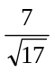 (B) 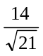 (C)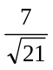 (D) 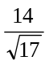

Sol. The length of latus rectum
= 2 × perp. from focus to the directrix
= 2 × 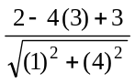 =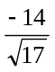
The numerical length = Ans. [D]

Note:- The negative sign of the latus rectum may only be ignored if its length is asked. For other calculations it should be used.
Ex.7 The coordinates of an endpoint of the latus rectum of the parabola (y – 1)2 = 4(x + 1) are
(A) (0,–3) (B) (0,–1)
(C) (0,1) (D) (1, 3)
Sol. Shifting the origin at (–1, 1) we have
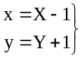 ...(i)
Using (i), the given parabola becomes.
Y2 = 4X
The coordinates of the endpoints of latus rectum are
(X = 1, Y = 2) and (X =1, Y= –2)
Using (i), the coordinates of the end point of the latus rectum are (0,3) and (0, –1)
Ans. [B]

Ex.8 The length of the chord of parabola x2 = 4ay passing through the vertex and having slope tan α is -
(A) 4a cosec α cot α (B) 4a tan α sec α
(C) 4a cos α cot α (D) 4a sin α tan α
Sol. Let A be the vertex and AP be a chord of
x2 = 4ay such that slope of AP is tan α. Let the coordinates of P be(2at, at2) Then,
Slope of AP = 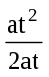 =
⇒ tan α = ⇒ t = 2 tan α
Now, AP
= 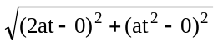= at 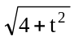
= 2a tan α 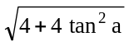 = 4a tan α sec α
Ans. [B]

Ex.9 The point on y2 = 4ax nearest to the focus has its abscissa equal to -
(A) –a (B) a (C) a/2 (D) 0
Sol. Let P(at2, 2at) be a point on the parabola
y2 = 4ax and S be the focus of the parabola. Then, SP = a + at2
[ focal distance = x + a]
Clearly, SP is least for t = 0.
Hence, the abscissa of P is at2 = a × 0 = 0
Ans. [D]

Ex.10 The common tangent of the parabola
y2 = 8ax and the circle x2 + y2 = 2a2 is -
(A) y = x + a (B) y = x – a
(C) y = x –2a (D) y = x + 2a
Sol. Any tangent to parabola is
y = mx + 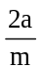
Solving with the circle
x2 + (mx + )2 = 2a2
B2 – 4ac = 0 gives m = ± 1
Otherwise
Perp. from (0, 0) = radius a 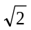
∴ 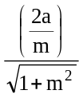= a ⇒ m = ± 1
Tangent y = ± x ± 2a
∴ y = x + 2a is correct option. Ans. [D]

Ex.11 The slope of tangents drawn from a point
(4, 10) to the parabola y2 = 9x are-
(A) 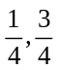 (B) 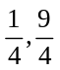
(C) 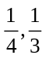 (D) None of these
Sol. The equation of a tangent of slope m to the parabola y2 = 9x is
y = mx + 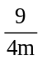
If it passes through (4, 10), then
10 = 4m + ⇒ 16m2 – 40m + 9 = 0
⇒ (4m –1)(4m –9) = 0 ⇒ m Ans. [B]

Ex.12 Tangents are drawn from the point (–2, –1) to the parabola y2 = 4x. If α is the angle between these tangents then tan α equals -
(A) 3 (B) 2 (C) 1/3 (D) 1/2
Sol. Any tangent to y2 = 4x is
y = mx + 1/m
If it is drawn from (–2, –1), then
–1 = –2m + 1/m
⇒ 2m2 – m – 1 = 0
If m = m1, m2 then m1 + m2 =1/2,
m1m2 =–1/2
∴ tan a 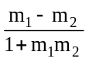 = 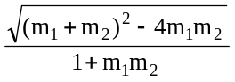
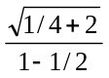 = 3 Ans. [A]

Ex.13 If the straight line x + y = 1 is a normal to the parabola x2 = ay, then the value of a is -
(A) 4/3 (B) 1/2 (D) 3/4 (D) 1/4
Sol. We know that equation of normal to the parabola x2 = ay is
y =mx +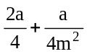
Given that x + y = 1 or y = –x + 1 is normal to the parabola therefore
m = –1 and +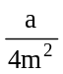 = 1
∴ + = 1⇒ 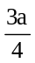 = 1⇒ a = Ans. [A]
Ex.14 If line y = 2x + k is normal to the parabola
y2 = 4x at the point (t2, 2t), then -
(A) k = –12, t = –2 (B) k = 12, t = –2
(C) k = 12, t = 2 (D) None of these
Sol. Since normal to the parabola y2 = 4x at (t2, 2t) is y + tx = 2t + t3.
Comparing it with y = 2x + k, we get
t = –2, k = 2t + t3 = –12 Ans. [A]
Ex.15 Which of the following lines, is a normal to the parabola y2 = 16x
(A) y = x – 11 cosθ – 3 cos 3θ
(B) y = x – 11 cosθ – cos 3θ
(C) y = (x – 11) cosθ + cos 3θ
(D) y = (x – 11) cosθ – cos 3θ

Sol. Here a = 4
condition of normality c = –2am – am3
(1) and (2) are not clearly the answer as
m = 1 for (3), (4) m = cosθ
c = –2(4) cosθ – 4 cos3θ
= – 8 cosθ – (3 cosθ + cos 3θ)
= –11 cosθ – cos 3θ
Hence (D) is correct Ans. [D]

Ex.16 If the tangents at P and Q on a parabola (whose focus is S) meet in the point T, then SP, ST and SQ are in -
(A) H.P. (B) G.P.
(C) A.P. (D) None of these
Sol. Let P (at12, 2at1) and Q (at22, 2at2) be any two points on the parabola y2 = 4ax, then point of intersection of tangents at P and Q will be
T ≡ [at1t2,a(t1+ t2)]
Now SP = a(t12 + 1)
SQ = a(t22 + 1)
ST =a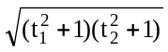
∴ ST2 = SP.SQ
∴ SP, ST and SQ are in G.P. Ans. [B]
Ex.17 If the distance of 2 points P and Q from the focus of a parabola y2 = 4ax are 4and 9 respectively, then the distance of the point of intersection of tangents at P and Q from the focus is
(A) 8 (B) 6
(C) 5 (D) 13
Sol. If S is the focus of the parabola and T is the point of intersection of tangents at P and Q, then
ST2 = SP × SQ ⇒ ST2 = 4 × 9 ⇒ ST = 6 Ans. [B]

level- 1



Q.1 The equation of the directrix of the parabola
x2 = – 8y is
(A) x = 2 (B) y =2
(C) y = –2 (D) x = –2

Q.2 The equation to the parabola whose focus is
(0, –3) and directrix is y = 3 is
(A) x2 = –12y (B) x2 = 12y
(C) y2 = 12x (D) y2 = –12x

Q.3 If (0, 0) be the vertex and 3x – 4y + 2 = 0
be the directrix of a parabola, then the length
of its latus rectum is
(A) 4/5 (B) 2/5
(C) 8/5 (D) 1/5

Q.4 If 2x + y + λ = 0 is a focal chord of the parabola
y2 = – 8x, then the value of λ is
(A) –4 (B) 4
(C) 2 (D) –2

Q.5 The focal distance of a point(x1, y1) on the
parabola y2 = 12x is
(A) x1 + 3 (B) x1 + 6
(C) y1 + 6 (D) y1 + 3

Q.6 The vertex of a parabola is (a,b) and its latus rectum is l. If the axis of the parabola is along the positive direction of y-axis, then its equation is-
(A) (x + a)2 = 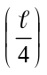 (2y – 2b)
(B) (x – a)2 = 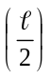 (2y – 2b)
(C) (x + a)2 = (2y – 2b)
(D) (x – a)2 = 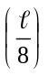 (2y – 2b)

Q.7 The length of latus rectum of the parabola
x2 = –y is-
(A) 1 (B) 1/4
(C) 4 (D) 1/2

Q.8 The distance between the focus and the directrix of the parabola x2 = –8y, is-
(A) 8 (B) 2
(C) 4 (D) 6

Q.9 If focus of the parabola is (3,0) and length of latus rectum is 8, then its vertex is-
(A) (2, 0) (B) (1, 0)
(C) (0, 0) (D) (–1, 0)

Q.10 For any parabola focus is (2,1) and directrix is
2x – 3y + 1 = 0, then equation of the latus rectum is-
(A) 3x + 2y + 8 = 0 (B) 2x – 3y – 1 = 0
(C) 2x – 3y + 1 = 0 (D) 3x – 2y + 4 = 0

Q.11 If (a, b) is the mid point of a chord passing through the vertex of the parabola y2 = 4x, then-
(A) a = 2b (B) 2a = b
(C) a2 = 2b (D) 2a = b2

Q.12 The area of the triangle formed by the lines joining the vertex of the parabola x2 = 12y to the ends of its latus rectum is-
(A) 16 sq. units (B) 12 sq. units
(C) 18 sq. units (D) 24 sq. units

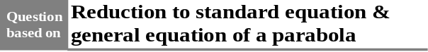

Q.13 Vertex of the parabola 9x2 –6x + 36y +9 = 0 is-
(A) (1/3, –2/9) (B) (–1/3, 1/2)
(C) (–1/3, –1/2) (D) (1/3, 1/2)

Q.14 The equation of the latus rectum of the
parabola x2 + 4x +2y = 0 is-
(A) 3y = 2 (B) 2y + 3 = 0
(C) 2y = 3 (D) 3y + 2 = 0

Q.15 The focus of the parabola y2 – x – 2y + 2 = 0 is-
(A) (1,2) (B) (1/4,0)
(C) (3/4, 1) (D) (5/4, 1)

Q.16 Vertex of the parabola y2 + 2y + x = 0 lies in the quadrant
(A) Second (B) First
(C) Third (D) Fourth

Q.17 The equation of the axis of the parabola
x2 – 4x–3y+10 = 0 is
(A) y + 2 = 0 (B) x + 2 = 0
(C) x – 2 = 0 (D) y – 2 = 0

Q.18 The vertex of the parabola x2+ 4x + 2y – 7 = 0 is-
(A) (– 2, 2) (B) (2, 11)
(C) (– 2, 11) (D) (– 2, 11/2)

Q.19 The latus rectum of the parabola
y2 – 4y – 2x – 8 = 0 is-
(A) 3 (B) 2
(C) 1 (D) 4

Q.20 The point of intersection of the latus rectum and axes of the parabola y2 + 4x + 2y – 8 = 0 is
(A) (5/4, –1) (B) (7/5, 5/2)
(C) (9/4, –1) (D) None of these

Q.21 The length of the latus rectum of the parabola
x = ay2 + by + c is-
(A) (B)
(C) (D) 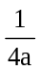

Q.22 Which of the following is not the equation of parabola
(A) 4x2 + 9y2 –12xy + x + 1 = 0
(B) 4x2 – 12xy + 9y2 + 3x + 5 = 0
(C) 2x2 + y2 – 4xy = 8
(D) 4x2 + 9y2 – 12xy + x + 1 = 0

Q.23 Which one is the equation of the parabola
(A) (x – y)2 = 2 (B) 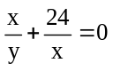
(C) 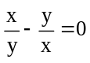 (D) 2x2 + 5y2 = 7

Q.24 The equation ax2 + 2hxy + by2 + 2gx + 2fy + c= 0 represents a parabola, if-
(A) a = b= 1, h = 0 (B) a = b, h = 0
(C) h2 = ab (D) None of these

Q.25 Given the ends of latus rectum, the number of parabolas that can be drawn is-
(A) 0 (B) 1
(C) 2 (D) 3



Q.26 If (0, a) be the vertex and (0, 0) be the focus
of a parabola then its equation will be
(A) y2 = 4a(a + x) (B) x2 = 4a(a – y)
(C) x2 = 4a(a + y) (D) y2 = 4a(a – x)

Q.27 If vertex and focus of a parabola are on
x- axis and at distances p and q respectively
from the origin, then its equation is-
(A) y2 = –4(p – q) (x + p)
(B) y2 = 4(p – q) (x – p)
(C) y2 = –4(p – q) (x – p)
(D) None of these

Q.28 Find the equation of the parabola having the vertex at (0,1) and the focus at (0,0)
(A) x2 + 4y – 4 = 0 (B) x2 + 4y + 4 = 0
(C) x2 – 4y + 4 = 0 (D) x2 – 4y – 4 = 0

Q.29 If (2, 0) and (5, 0), are the vertex and focus of a parabola respectively then its equation is
(A) y2 = –12x –24 (B) y2 = 12x – 24
(C) y2 = 12x + 24 (D) y2 = –12x + 24

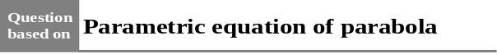

Q.30 x– 2 = t2, y = 2t are the parametric equations of the parabola-
(A) y2 = –4x (B) y2 = 4x
(C) x2 = – 4y (D) y2 = 4 (x– 2)

Q.31 The equations x =, y = 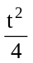 represents-
(A) An ellipse (B) A parabola
(C) A circle (D) A hyperbola

Q.32 The parametric equation of a parabola is
x = t2 + 1, y = 2t + 1. The Cartesian equation of its directrix is-
(A) x = 0 (B) y = 0
(C) x + 1 = 0 (D) None of these

Q.33 Any point on the parabola whose focus is
(0, 1) and the directrix is x + 2 = 0 is given by-
(A) (t2 + 1, 2t + 1) (B) (t2 + 1, 2t – 1)
(C) (t2, 2t) (D) (t2 – 1, 2t+1)

Q.34 Which of the following are not parametric
coordinates of any point on the parabola
y2 = 4ax
(A) (a/m2, 2/m) (B) (a, 2a)
(C) (at2, 2at) (D) (am2, – 2am)

Q.35 The parametric equations of the parabola
y2 – 12 x – 2y – 11 = 0 are-
(A) x = 3t2 – 1, y = 6t + 1
(B) x = 3t2 + 1, y = 6t – 1
(C) x = 6t + 1, y = 3t2 – 1
(D) None of these

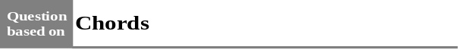

Q.36 In the parabola y2 = 6x, the equation of the
chord through vertex and negative end of latus
rectum, is -
(A) x = 2y (B) y + 2x = 0
(C) y = 2x (D) x + 2y = 0

Q.37 If (2,–8) is at an end of a focal chord of the
parabola y2 = 32 x then the other end of the
chord is-
(A) (32, 32) (B) (–2, 8)
(C) (32, –32) (D) None of these

Q.38 The length of the chord of the parabola
y2 = 4x which passes through the vertex and
makes 30º angle with x- axis is-
(A) 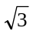/2 (B) 3/2
(C) 8 (D)

Q.39 Lines y = x and y = –x intersect the parabola
y2 = 4x at A and B other than the origin. The length AB is
(A) 12 (B) 8
(C) 4 (D) 16

Q.40 The length of the chord passing through the vertex of the parabola y2 = 4ax and making an angle θ with x-axis is
(A) 4a sin θ cos2 θ (B) 4a cos θ cosec2 θ
(C) 4a sin θ sec2 θ (D) 4a cos θ sin2 θ

Q.41 The length of the intercept made by the parabola x2 –7x +4y +12= 0 on x-axis is
(A) 4 (B) 3
(C) 1 (D) 2

Q.42 The length of the intercept made by the parabola 2y2 + 6y = 8 – 5x on y-axis is
(A) 7 (B) 5
(C) 3 (D) 1

Q.43 Length of the chord intercepted by the parabola y = x2 + 3x on the line x + y = 5 is
(A) 6 (B)
(C) 6 (D) None of these

Q.44 If PSQ is the focal chord of the parabola
y2 = 8x such that SP = 6. Then the length
SQ is-
(A) 4 (B) 6
(C) 3 (D) None of these

Q.45 If length of the two segments of focal chord to the parabola y2 = 8ax are 2 and 4, then the value of a is-
(A) 1/3 (B) 2/3
(C) 4/3 (D) 4

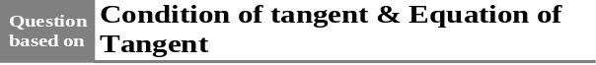

Q.46 If the line x + y –1 = 0 touches the parabola
y2 = kx, then the value of k is-
(A) 2 (B) –4
(C) 4 (D) –2
Q.47 The straight line x + y = k touches the parabola y = x – x2, if k =
(A) 0 (B) – 1
(C) 1 (D) None of these

Q.48 The line y = mx + c may touch the parabola
y2 = 4a (x + a), if-
(A) c = am – (a/m) (B) c = a/m
(C) c = – a/m (D) c = am + (a/m)

Q.49 The straight line 2x + y –1= 0 meets the parabola y2 = 4x in
(A) Two real and different points
(B) Two imaginary points
(C) Two coincident points
(D) One real point and one point at infinity

Q.50 The line x + my + n = 0 will touch the parabola y2 = 4ax, if
(A) m = an2 (B) mn = a2
(C) n = am2 (D) mn = a

Q.51 For what value of k, the line 2y – x + k = 0 touches the parabola x2 + 4y = 0-
(A) 2 (B) –1/2
(C) –2 (D) 1/2
Q.52 At which point the line x = my + 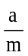 touches
the parabola x2 =4ay
(A) (2am, am2) (B) (am2 , 2am)
(C) 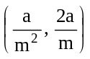 (D) 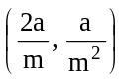
Q.53 If a tangent to the parabola 4y2 = x makes
an angle of 60º with the x- axis, then its
point of contact is-
(A) 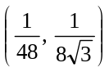 (B) 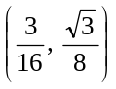
(C) 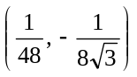 (D) 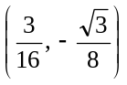

Q.54 The equation of the tangent to the parabola
y2 = 4x at the point (1, 2) is-
(A) x – y + 1 = 0 (B) x + y – 1 = 0
(C) x + y + 1 = 0 (D) x – y – 1 = 0

Q.55 The point where the line x + y = 1 touches
the parabola y = x– x2 , is-
(A) 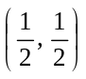 (B) (1,0)
(C) (0,1) (D) (– 1,–2)
Q.56 The equation of the tangent at vertex to the
parabola 4y2 + 6x = 8y + 7 is
(A) x = 11/6 (B) y = 2
(C) x = –11/6 (D) y = – 2

Q.57 The equation of the tangent to the parabola
y = 2 + 4x –4x2 with slope –4 is
(A) 4x + y – 6 = 0 (B) 4x + y + 6 = 0
(C) 4x – y – 6 = 0 (D) None of these

Q.58 The point on the curve y2 = x the tangent at which makes an angle of 45º with x-axis will be given by
(A) (1/2, 1/2) (B) (1/2, 1/4)
(C) (2,4) (D) (1/4,1/2)

Q.59 The point of contact of the line 2x – y + 2 = 0 with the parabola y2 = 16 x is-
(A) (3,4) (B) (2,4)
(C) (1,4) (D) (–2, 1)

Q.60 The equation of tangent to the parabola
x2 = y at one extremity of latus rectum in the first quadrant is
(A) y = 4x + 1 (B) x = 4y +1
(C) 4x + 4y = 1 (D) 4x – 4y = 1

Q.61 The equation of the common tangents to the parabolas y2 = 4x and x2 = 32y is-
(A) x + 2y = 4 (B) x = 2y + 4
(C) x = 2y – 4 (D) x + 2y + 4 = 0

Q.62 Area of triangle formed by the tangents at three points t1, t2 and t3 of the parabola y2 = 4ax is-
(A) (t1 – t2) (t2– t3) (t3– t1)
(B) a2 (t1 – t2) (t2– t3) (t3– t1)
(C) 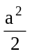 (t1 + t2) (t2+ t3) (t3+ t1)
(D) (t1 – t2) (t2– t3) (t3– t1)

Q.63 The abscissa of the point of intersection of two tangents to the parabola is the .....between the abscissa of the points contact.
(A) H.M. (B) G.M.
(C) A.M. (D) None of these

level- 2

Q.1 A tangent to the parabola y2 = 4ax at P (p, q) is perpendicular to the tangent at the other point Q, then coordinates of Q are-
(A) (a2/p, – 4a2/q) (B) (–a2/p, – 4a2/q)
(C) (–a2/p, 4a2/q) (D) (a2/p, 4a2/q)

Q.2 The coordinates of a point on the parabola
y2 = 8x whose focal distance is 4 is-
(A) (2,4) (B) (4,2)
(C) (2,–9) (D) (4,–2)

Q.3 PQ is a double ordinate of y2 = 4ax. The locus of its point of trisection is
(A) y2 = 2ax (B) 3y2 = 4ax
(C) 9y2 = 4ax (D) 9y2 = 2ax

Q.4 Which one of the following represented parametrically, represents equation of a parabola-
(A) x = 3 cos t; y = 4 sin t
(B) x2 – 2 = –2 cos t; y = 4 cos2
(C) 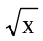 = tan t; 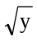= sec t
(D) x =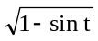; y = sin + cos

Q.5 If (x1 ,y1) and (x2, y2) and ends of a focal chord of the parabola y2 = 4ax, then square of G.M. of x1 and x2 is-
(A) –4a2 (B) 4a2 (C) a2 (D) –a2

Q.6 The equation of the common tangent to the parabolas y2 = 4ax and x2 = 4by is
(A) xa1/3 + yb1/3 + (ab)2/3 = 0
(B) xa2/3 + yb2/3 + (ab)2/3 = 0
(C) xa1/3 + yb1/3 = (ab)2/3
(D) xa2/3 + yb2/3 = (ab)2/3

Q.7 If the chord y = mx + c subtends a right angle at the vertex of the parabola y2 = 4ax, then the value of c is-
(A) –4am (B) 4am (C) –2am (D) 2am

Q.8 The length of L.R. of the parabola
y = x tanα – 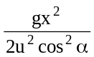 is-
(A) 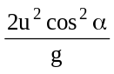 (B) 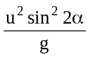
(C) 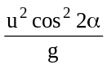 (D) None of these

Q.9 If a tangent line at a point P on a parabola makes angle α with its focal distance, then angle between the tangent and axis of the parabola is-
(A) α (B) α/2
(C) 2α (D) 90º

Q.10 If a focal chord of parabola y2 = 4ax makes an angle θ with its axis, then the length of perpendicular from vertex to this chord is-
(A) a tan θ (B) a cos θ
(C) a sin θ (D) a sec θ

Q.11 An equilateral triangle is inscribed in the parabola y2 = 4x whose vertex is at the vertex of the parabola. The area of this triangle is-
(A) 48 (B) 16
(C) 64 (D) 8

Q.12 The equation of common tangent to the circle
x2 + y2 = 2a2 and parabola y2 = 8ax is-
(A) y = x + a (B) y = ±x ± 2a
(C) y = –x + a (D) y = –x + 2a

Q.13 The equation of a tangent to the parabola
y2 = 12x is y = x + 3. The point on this line from which other tangent to the parabola is perpendicular to the given tangent is-
(A) (0, 4) (B) (–3, 3)
(C) (–2, 3) (D) None of these

Q.14 The locus of the point of intersection of perpendicular tangent to the parabola
x2 – 8x + 2y + 2 = 0 is-
(A) 2y – 15 = 0 (B) 2y + 15 = 0
(C) 2x + 9 = 0 (D) None of these

Q.15 The slope of tangent lines drawn from (3, 8) to the parabola y2 = –12x are-
(A) 3, 1/3 (B) –3, –1/3
(C) 3, –1/3 (D) –3, 1/3

Q.16 The equation of the common tangent of the parabolas x2 = 108y and y2 = 32x, is-
(A) 2x + 3y = 36 (B) 2x + 3y + 36 = 0
(C) 3x + 2y = 36 (D) 3x + 2y + 36 = 0

Q.17 On the parabola y = x2, the point least distance from the straight line y = 2x – 4 is-
(A) (1, 1) (B) (1, 0)
(C) (1, –1) (D) (0, 0)

Q.18 AB, AC are tangents to a parabola y2 = 4ax. If 1, 2, 3 are the lengths of perpendiculars from A, B, C on any tangent to the parabola, then-
(A) 1, 2, 3 are in GP
(B) 2, 3, 1 are in GP
(C) 3, 1, 2 are in GP
(D) None of these

Q.19 A circle with centre at the focus of the parabola y2 = 4px touches the directrix. Then a point of intersection of the circle and the parabola is-
(A) (–p, 2p) (B) (p, –2p)
(C) (p, ±2p) (D) (–p, –2p)

Q.20 An equilateral triangle is inscribed in the parabola y2 = 4ax with one vertex at the origin. The radius of the circum circle of that triangle is-
(A) 2a (B) 4a (C) 6a (D) 8a

Q.21 L(2, 4) and L′(2, –4) are the ends of the latus- rectum of a parabola. P is a point on the directrix. Then the area of ΔPLL′ =
(A) 16 (B) 8
(C) 4 (D) 1

Q.22 The equation of the locus of a point which moves so as to be at equal distances from the point (a, 0) and the y-axis is
(A) y2 –2ax + a2 = 0 (B) y2 + 2ax + a2 = 0
(C) x2 –2ay + a2 = 0 (D) x2 + 2ay + a2 = 0

Q.23 If the line x + my + n = 0 is a tangent to the parabola y2 = 4ax, then locus of its point of contact is
(A) a straight line (B) a circle
(C) a parabola (D) two straight lines

Q.24 M is the foot of the ⊥ from a point P on the parabola y2 = 8(x –3) to its directrix and S is the focus of the parabola and SPM is an equilateral triangle, then the length of each side of the triangle is
(A) 2 (B) 3 (C) 4 (D) 8

Q.25 Equation of the directrix of the parabola whose focus is (0, 0) and the tangent at the vertex is
x – y + 1 = 0 is
(A) x – y = 0 (B) x – y – 1 = 0
(C) x – y + 2 = 0 (D) x + y – 1 = 0

Q.26 The point on y2 = 4ax nearest to the focus has its abscissae equal to
(A) –a (B) a
(C) a/2 (D) 0

Q.27 The tangents at the points (at12, 2at1), (at22, 2at2) on the parabola y2 = 4ax are at right angles if
(A) t1t2 = –1 (B) t1t2 = 1
(C) t1t2 = 2 (D) t1t2 = –2

level- 3

Q.1 The angle subtended by the double ordinate of length 2a of the parabola y2 = ax, at the vertex is equals to-
(A) (B)
(C) (D) none of these

Q.2 The portion of a tangent to a parabola y2 = 4ax cut off between the directrix and the curve subtends an angle θ at the focus, then θ is equal to -
(A) (B)
(C) (D) none of these

Q.3 If three points E, F, G are taken on the parabola
y2 = 4ax so that their ordinates are in G.P., then the tangents at E and G intersect on the-
(A) directrix (B) axis
(C) abscissa of F (D) ordinate of F

Q.4 A circle has its centre at the vertex of the parabola x2 = 4y and the circle cuts the parabola at the ends of its latus rectum. The equation of the circle is-
(A) x2 + y2 = 5 (B) x2 + y2 = 4
(C) x2 + y2 = 1 (D) none of these

Q.5 A triangle ABC of area 5a2 is inscribed in the parabola y2 = 4ax such that vertex A lies at the vertex of parabola and BC is a focal chord. Then the length of focal chord is-
(A) 5a (B) 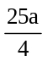 (C) 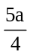 (D) 25a

Q.6 The equation of directrix of a parabola is
3x + 4y + 15 = 0 and equation of tangent at vertex is 3x + 4y – 5 = 0. Then the length of latus rectum is equal to
(A) 15 (B) 14 (C) 13 (D) 16

Q.7 For the parabola y2 + 8x – 12y + 20 = 0, which of the following is not correct-
(A) vertex (2, 6)
(B) focus (0, 6)
(C) length of the latus rectum = 4
(D) axis is y = 6

Q.8 Length of the tangent drawn from an end of the latus rectum of the parabola y2 = 4ax to the circle of radius a touching externally the parabola at vertex is equal to-
(A) a (B) 2a
(C) 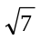 a (D) 3a

Q.9 The vertex of parabola is (2, 2) and the
co-ordinates of extremities of latus rectum are
(–2, 0) & (6, 0). The equation of parabola is equal to-
(A) y2 – 4y + 8x – 12 = 0
(B) x2 + 4x – 8y – 12 = 0
(C) x2 – 4x + 8y – 12 = 0
(D) x2 – 8y – 4x + 20 = 0

Q.10 If M is the foot of perpendicular from a point P of a parabola y2 = 4ax to its directrix and SPM is an equilateral triangle, where S is the focus. Then SP equal to-
(A) a (B) 2a
(C) 3a (D) 4a

Q.11 If the point P(2, –2) is the one end of the focal chord PQ of the parabola y² = 2x then slope of the tangent at Q is-
(A) –2 (B) 2
(C) 1/2 (D) –1/2

Assertion-Reason type Question:
Note : Question Number 12 to 19 are assertion-reason type question. Each question has two statements. (Statement-1 and Statement-2) Each question has four options A, B, C and D. Out of which only one is correct.
A → If both statements are correct and Statement (2) is correct explanation of statement (1).
B → If both statements are correct but Statement (2) is not correct explanation of statement (1).
C → If statement (1) is correct and statement (2) is wrong.
D → If statement (1) is wrong and statement (2) is correct.

Q.12 Statement-(1): The curve 9y2 –16x –12y –57 = 0 is symmetric about line 3y = 2.
Statement- (2): A parabola is symmetric about it’s axis.

Q.13 Statement- (1): Two perpendicular tangents of parabola
y2 = 16x always meet on x + 4 = 0.
Statement-(2): Two perpendicular tangents of a parabola, always meets on axis.

Q. 14 Statement-(1) : If 4 & 3 are length of two focal segments of focal chord of parabola y2 = 4ax than latus rectum of parabola will be 48/7 units
Statement-(2) : If 1 & 2 are length of focal segments of focal chord than its latus rectum is 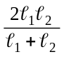 .

Q.15 Statement-(1) : Let (x1, y1) and (x2, y2) are the ends of a focal chord of y2 = 4x then 4x1x2 + y1y2 =0
Statement-(2) : PSQ is the focal of a parabola with focus S and latus rectum λ then SP + SQ = 2λ.

Q.16 Statement-(1) : Straight line y + x = k touch the parabola y = x –x² if k = 1
Statement-(2) : Discriminant of (x –1)² = x –x² is zero.
Q.17 Statement- (1) : PQ is a focal chord of a parabola. Then the tangent at P to the parabola is parallel to the normal at Q.
Statement-(2): If P(t1) and Q(t2) are the ends of a focal chord of the parabola y2 = 4ax, then
t1t2 = –1.

Q.18 Statement-(1): The tangents drawn to the parabola y2 = 4ax at the ends of any focal chord intersect on the directrix.
Statement- (2) : The point of intersection of the tangents at drawn at P(t1) and Q(t2) are the parabola y2 = 4ax is {at1t2, a(t1 + t2)}

Q.19 Statement-(1) : The lines from the vertex to the two extremities of a focal chord of the parabola y² = 4ax are at an angle of .
Statement-(2) : If extremities of focal chord of a parabola are (at₁², 2at₁) and (at₂², 2at₂), then t₁t₂ = –1.

Passage-1 (Q. No. 20 to Q. No. 22)
A equilateral triangle is inscribed in the parabola y2 = 8x. If one vertex of the triangle is at the vertex of parabola then-

Q.20 Length of side of the triangle is-
(A) 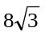 (B) 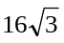
(C) 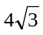 (D) 8

Q.21 Area of the triangle is-
(A) 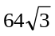 (B) 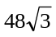
(C) 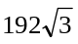 (D) None of these

Q.22 Radius of the circum-circle of the triangle is-
(A) 4 (B) 8 (C) 16 (D) 32

Passage- 2 (Q. No. 23 to Q. No. 25)

Conic possesses enormous properties which can be probed by taking their standard forms. Unlike circle these properties rarely follow by geometrical considerations. Most of the properties of conics are proved analytically. For example, the properties of a parabola can be proved by taking its standard equation y2 = 4ax and a point (at2, 2at) on it.

Q.23 If the tangent and normal at any point P on the parabola whose focus is S, meets its axis in T and G respectively, then
(A) PG = PT
(B) S is mid- point of T and G
(C) ST = 2SG
(D) None of these

Q.24 The angle between the tangents drawn at the extremities of a focal chord must be
(A) 30° (B) 60° (C) 90° (D) 120°

Q.25 If the tangent at any point P meets the directrix at K, then ∠KSP must be
(A) 30° (B) 60°
(C) 90° (D) None of these

Column matching questions

Q.26 Match the following :
Column-I Column-II
(A) The focus of the (P) (1, 2)
parabola (y – 4)2 = 12 (x – 2)
(B) The vertex of the parabola (Q) (–3, 1)
y2 –5x –4y + 9 = 0
(C) The foot of the directrix of the (R) (3, 0)
parabola x2 + 8y = 0
(D) The vertex of the parabola (S) (5, 4)
x2 + 6x –2y + 11 = 0 (T) (0, 2)

ANSWER KEY
level- 1
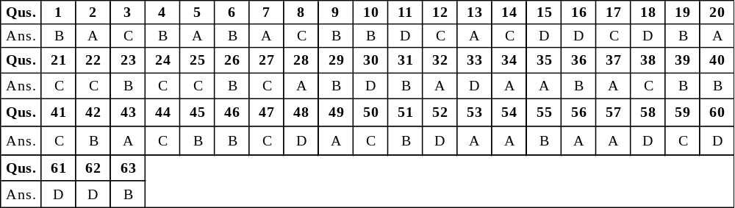
level- 2
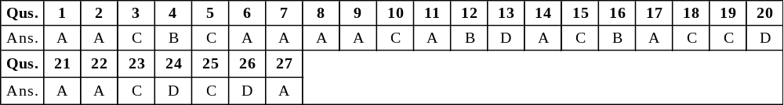
level- 3
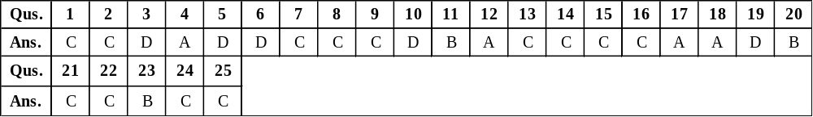

(26) A → S; B → P; C → T; D → Q

